***[Document Type]***

**Open API Conformance**

*[Subtitle]*

**[document number]**

**[Date]**

|  |  |
| --- | --- |
| **Latest Update: [update]** | **[Document Status]** |
| **Version [version number]** | **IPR Mode: [RAND]** |

Notice

Copyright © TM Forum 2017. All Rights Reserved.

This document and translations of it may be copied and furnished to others, and derivative works that comment on or otherwise explain it or assist in its implementation may be prepared, copied, published, and distributed, in whole or in part, without restriction of any kind, provided that the above copyright notice and this section are included on all such copies and derivative works. However, this document itself may not be modified in any way, including by removing the copyright notice or references to TM FORUM, except as needed for the purpose of developing any document or deliverable produced by a TM FORUM Collaboration Project Team (in which case the rules applicable to copyrights, as set forth in the [TM FORUM IPR Policy](http://www.tmforum.org/IPRPolicy/11525/home.html), must be followed) or as required to translate it into languages other than English.

The limited permissions granted above are perpetual and will not be revoked by TM FORUM or its successors or assigns.

This document and the information contained herein is provided on an “AS IS” basis and TM FORUM DISCLAIMS ALL WARRANTIES, EXPRESS OR IMPLIED, INCLUDING BUT NOT LIMITED TO ANY WARRANTY THAT THE USE OF THE INFORMATION HEREIN WILL NOT INFRINGE ANY OWNERSHIP RIGHTS OR ANY IMPLIED WARRANTIES OF MERCHANTABILITY OR FITNESS FOR A PARTICULAR PURPOSE.

Direct inquiries to the TM Forum office:

240 Headquarters Plaza,

East Tower – 10th Floor,

Morristown, NJ  07960 USA

Tel No.  +1 973 944 5100

Fax No.  +1 973 944 5110

TM Forum Web Page: [www.TM Forum.org](http://www.tmforum.org/)

Table of Contents

Notice 2

Table of Contents 3

1. The following guidelines will take you through the various steps needed to run self-testing for your API to achieve conformance certification. 4

1.1. Self-Certification is based on the TM Forum Open API conformance profiles, it is the process by which an implementation is confirmed to support the standard definition of a TM Forum Open API. Currently available c onformance profiles can be found through the following links: 4

1.2. The TM Forum provides a set of scripts useful to self-certify your implementation of TM Forum Open API specifications. You will need to install and run the applicable API CTK. Currently there is a limited number of CTKs available for conformance testing but the list is steadily increasing. The following is a list of APIs which have currently CTKs available for conformance testing: 5

2. The following instructions describe how to install an Open API CTK 6

2.1. Tools needed for Open API CTK testing and validation: 6

2.2. Once Node.js and Newman are installed follow the next steps: 6

2.2.1. 1 Import CTK from TM Forum 6

2.2.2. 2 Configure environment 6

2.2.3. 3 You need to create your testing environment. The environment is a text file without extension written in JSON. It has the following format: 7

2.2.5. You can use this as a template. Create a file with this format, replace the values for the name, the host and your API addresses and put it in the same folder as the postman collections. 7

2.2.6. 4 Now create the right script or batch file for your platform (either Windows or Linux/Mac), put it in the same folder and run script execution command. For example, you can use a batch file (runtest.bat) which would look like the following example: 7

2.2.7. If they are no failures, then you have passed the CTK and your API is conformant with all the Mandatory features. 8

2.2.8. The results of the CTK are in the DS TestedAPI CTKResult .html and should look like the following (example with Customer Management API): 8

2.2.9. All the information related to the execution of the CTK will be contained in the DS TestedAPI CTKResult .json file. 9

2.3. <<complete example for trouble ticket API goes here>> 9

2.4. [Need to populate the TM Forum page with test results by sending the files to <aanaya@ tmforum.org > to be uploaded to our TMF website] 9

2.4.1. The following link points to the TM Forum Open API Self Certification Web Page in which conformance results are published: 9

2.4.2. TM Forum Open API Self Certification Web Page 9

# The following guidelines will take you through the various steps needed to run self-testing for your API to achieve conformance certification.

## Self-Certification is based on the TM Forum Open API conformance profiles, it is the process by which an implementation is confirmed to support the standard definition of a TM Forum Open API. Currently available c onformance profiles can be found through the following links:

* **TMF661 Trouble Ticket API Conformance Profile R16.5.0**
* **[TMF660 Product Catalog API Conformance Profile R16.5.0](https://projects.tmforum.org/wiki/display/AP/TMF660+Product+Catalog+API+Conformance+Profile+R16.5.0?src=contextnavpagetreemode)**
* **[TMF659 Customer Management API Conformance Profile R16.5.0](https://projects.tmforum.org/wiki/display/AP/TMF659+Customer+Management+API+Conformance+Profile+R16.5.0?src=contextnavpagetreemode)**
* TMF637 Product Inventory Management API Conformance Profile R16.5
* TMF645 Service Qualification API Conformance Profile R16.5

## The TM Forum provides a set of scripts useful to self-certify your implementation of TM Forum Open API specifications. You will need to install and run the applicable API CTK. Currently there is a limited number of CTKs available for conformance testing but the list is steadily increasing. The following is a list of APIs which have currently CTKs available for conformance testing:

* **Trouble Ticket CTK (API REST Specification TMF661 - R16.5.0)**
* **Product Catalog Management CTK (API REST Specification TMF660 - R16.5.0)**
* **Customer Management CTK (API REST Specification TMF659 - R16.5.0 )**
* **Service Qualification CTK (API REST Specification TMF645 - R16.5.0)**
* **Product Inventory Management CTK (API REST Specification TMF637 - R16.5.0)**

# The following instructions describe how to install an Open API CTK

## Tools needed for Open API CTK testing and validation:

* **Newman (needed for CTK test execution), this is the command line version of 'Postman'; installation instructions available at: https://www.getpostman.com/docs/newman_intro**
* **Newman is built on Node.js. To run Newman, make sure you have Node.js installed. Node.js can be downloaded and installed from here on Linux, Windows, and Mac OSX.**
* **Node.js offers a server-side environment, which allows the use of JavaScript language to generate web pages. Basically, it replaces server languages such as PHP, Java EE, etc. Once Node.js is installed, Newman is just a command away:**
* **npm install -g newman**
* **This installs Newman from npm globally on your system allowing you to run it from anywhere.**
* **npm makes it easy for JavaScript developers to share and reuse code, and it makes it easy to update the code that you're sharing. (You can download npm from [here](https://www.npmjs.com/package/download)).**

## Once Node.js and Newman are installed follow the next steps:

### 1 Import CTK from TM Forum

* Download and unzip postman collection file for selected API from the corresponding page (see CTK links provided above)
* Store downloaded file into the folder in your system where Newman runs

### 2 Configure environment

* Download environment file (TMFENV) from the following link: [TMFENV File](https://projects.tmforum.org/wiki/display/AP/TMFENV+File)
* Modify environment file to refer to the endpoint where the implementation to be certified is running (see step 3 below)
* Store modified file into the folder in your system where Newman runs

### 3 You need to create your testing environment. The environment is a text file without extension written in JSON. It has the following format:

### 

### You can use this as a template. Create a file with this format, replace the values for the name, the host and your API addresses and put it in the same folder as the postman collections.

### 4 Now create the right script or batch file for your platform (either Windows or Linux/Mac), put it in the same folder and run script execution command. For example, you can use a batch file (runtest.bat) which would look like the following example:

set http_proxy=<http://proxyinternet.tesa:8080>  
newman -c DSTestedAPITestCollection.postman_collection -e TMFENV -H DSTestedAPICTKResult.html -o DSTestedAPICTKResult.json  
pause >nul

**5 A folder name results will be created and filled with the output of the tests. You should see something like the following:**

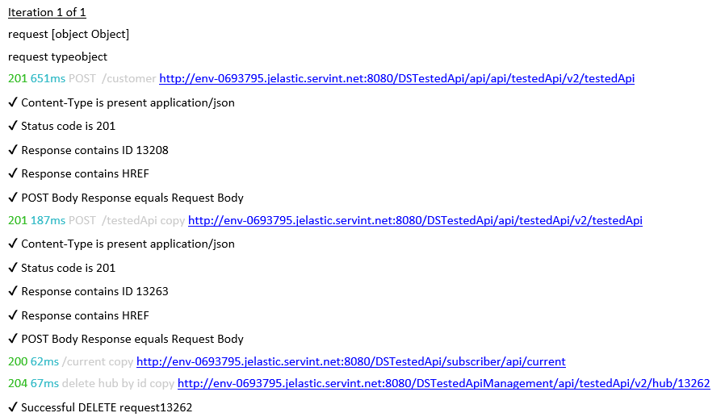

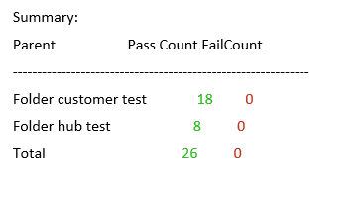

### If they are no failures, then you have passed the CTK and your API is conformant with all the Mandatory features.

### The results of the CTK are in the DS TestedAPI CTKResult .html and should look like the following (example with Customer Management API):

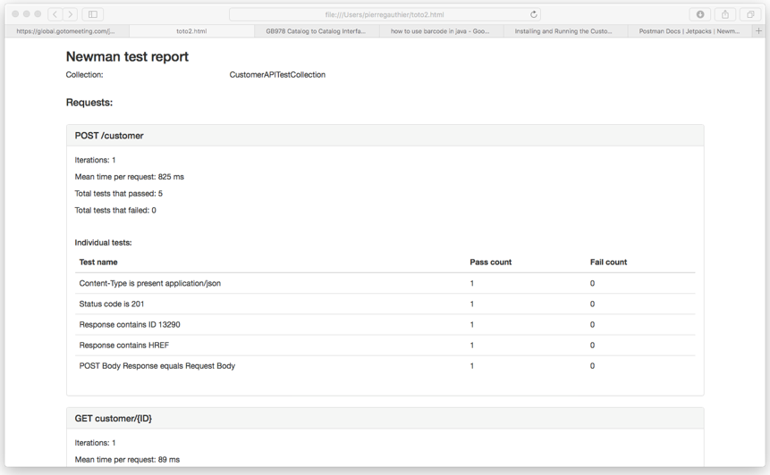

### All the information related to the execution of the CTK will be contained in the DS TestedAPI CTKResult .json file.

## <<complete example for trouble ticket API goes here>>

## [Need to populate the TM Forum page with test results by sending the files to <aanaya@ tmforum.org > to be uploaded to our TMF website]

### The following link points to the TM Forum Open API Self Certification Web Page in which conformance results are published:

### TM Forum Open API Self Certification Web Page

### 

You can also submit a link to your webpage… (TBD)